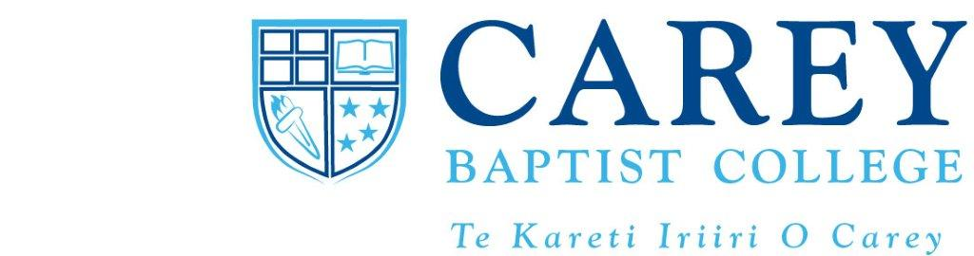
Christian Muslim Engagement
A two day block course: Friday 25 – Saturday 26 May 2012, 9.30am-4.30pm
With Dr Colin Edwards MBChB, DTM&H, DCH, BA (Hons) Theol
At Carey Baptist College, 473 Great South Road, Penrose, Auckland (Lecture Room 1)
Audit fee: $85
This module is part of a Carey course on Issues in Contemporary Mission, but it is being opened to other interested people.
How are Christians to receive and engage the Asian and Arab diaspora communities who now live in countries such as the UK, Australia and of course NZ? What do we need to understand and take into account?
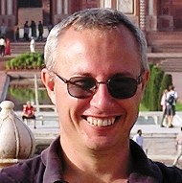
Colin Edwards is an ideal person to help us learn in this area. He is a Kiwi who trained as a medical doctor and spent 15 years in South Asia with Interserve. He and his family then moved to the UK where Colin is Team Leader for Urban Vision, Interserve's cross cultural work in England and Wales, training and equipping people to engage cross culturally. He also teaches at Redcliffe College (UK) on Muslim Christian relations, looking particularly at socio-cultural aspects and interfaith dialogue, and he is currently working on PhD research on the theology of churches growing in Muslim contexts.

The course will include an introduction to Islam, its socio-cultural dynamics, the life of Muhammad, the holy texts of Islam (Qur’an and Hadith), and various types of Islam. We shall then consider Jesus in Islam and various aspects of contextualization in evangelism and in developing theologies in Muslim contexts, including NZ.

To register and pay, contact Neroli Hollis (academic registrar):
neroli.hollis@carey.ac.nz (09 526 0340)

